Achievements of the Department
- Research Publication:
Departmental Research Journal “Danish”
with ISSN No. 0975-6566(UGC– enlisted)
brought out regularly.
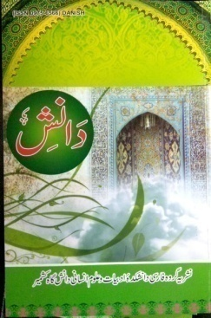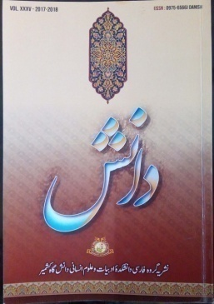

- Seminars/Workshops:

Seminars Organized (International)
- Three Day International Seminar on Maulana Jalau-ud-Din Rumi & his Contribution in Persian Sufism on 18th to 20th June 2012.
- Three Day International Seminar on “Emergence of Moral and Ethical values in Indo-Iranian Persian Literature and its relevance in Modern times” sponsored by Fakhrud-Din Ali Ahmed Committee Lucknow (U.P) on 21st to 23rd June,2018.

Seminars Organized (National)
- 03 Day National Seminar sponsored by NMM, New Delhi on 18th to 20th June 2013.
- 02 Day National seminar on “Manuscripts Heritage of Kashmir: with Special Reference to Persian Collection” sponsored by IGNCA, New Delhi on 30th to 31st October 2018.

Workshops Conducted
- 21 Day workshop sponsored by National Mission for Manuscripts, Ministry of Culture,
Govt. of India on 15th March to 6th April 2013.
- 05 Day National Level Workshop on Preventive Contribution of Manuscripts sponsored by
NMM, New Delhi on 6th to 10th April 2015.
